DBMS LAB MANUAL

Name: NITHIN KUMAR K Roll.No: 230701217

**Using set operations**

**Ex.No.7:**

1.SELECT DEPT_ID FROM JOB MINUS SELECT DEPT_ID FROM JOB WHERE JOB_ID='CLERK';

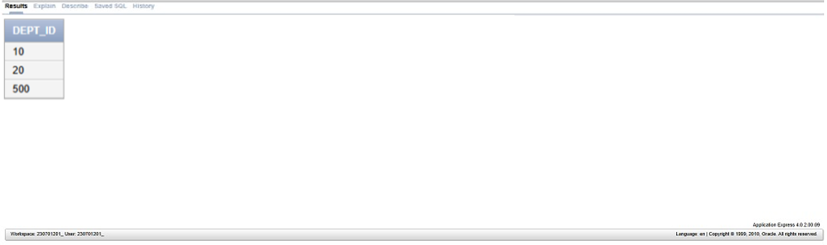

2. SELECT COUNTRY_NAME,COUNTRY_ID FROM JOB MINUS SELECT

COUNTRY_NAME,COUNTRY_ID FROM JOB WHERE DEPT_ID IS NOT NULL;

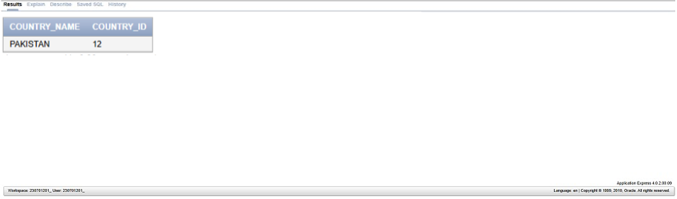

3. SELECT JOB_ID,DEPT_ID FROM JOB WHERE DEPT_ID= 10 UNION

SELECT JOB_ID,DEPT_ID FROM JOB WHERE DEPT_ID= 50 UNION

SELECT JOB_ID,DEPT_ID FROM JOB WHERE DEPT_ID= 20;

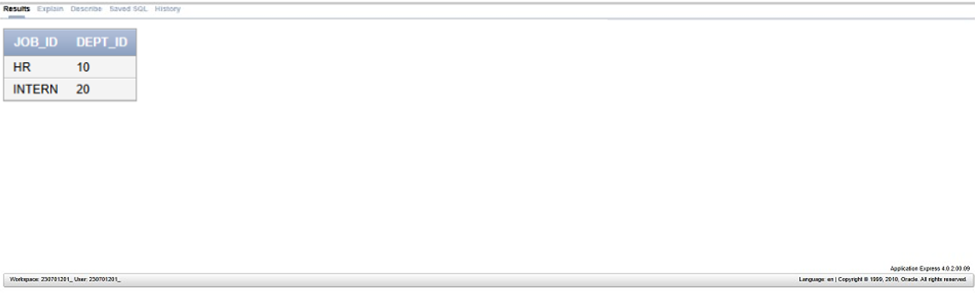

4. SELECT EMP_ID,JOB_ID FROM JOB INTERSECT SELECT EMP_ID,JOB_ID FROM JOB_HISTORY;

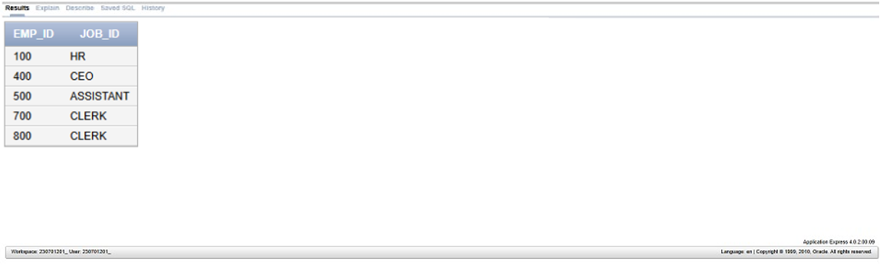

5. SELECT DEPT_ID,EMP_ID FROM JOB;

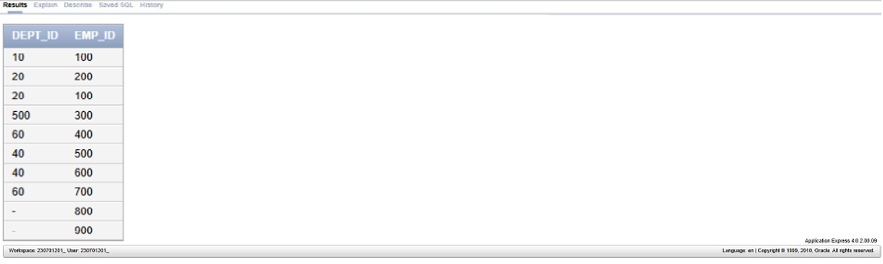

6. SELECT LAST_NAME,DEPT_ID FROM EM1 UNION ALL

SELECT NULL AS LAST_NAME,DEPT_ID FROM JOB;

